**Project Design Phase-II**

**Data Flow Diagram & User Stories**

|  |  |
| --- | --- |
| Date | 22 October 2023 |
| Team ID | 591236 |
| Project Name | Chinese Debt Trap: Insights on money lending patterns |
| Maximum Marks | 10 Marks |

**Data Flow Diagrams:**

A Data Flow Diagram (DFD) is a traditional visual representation of the information flows within a system. A neat and clear DFD can depict the right  amount of the system requirement graphically. It shows how data enters and leaves the system, what changes the information, and where data is  stored.

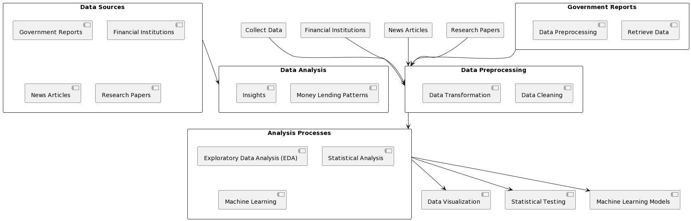

User Stories

|  |  |  |  |  |  |  |
| --- | --- | --- | --- | --- | --- | --- |
| User Type | Functional  Requirements (Epic) | User Story | User Story/Task | Acceptance Criteria | Priority | Release |
| Borrowing Country | Data collection and analysis | 1 | As a citizen of Borrowing Country, want to ensure transparent data collection and analysis of loan terms and financial impacts to make good and mindful decisions. | Provide historical data on financial impacts of previous Loans  System generates reports with data insights and trends for decision makers | High | 1 |
|  |  | 2 | Access to historical data on financial impacts of loans to identify trends and area of improvement | Data is presented using simple format for easy understanding  Develop strategies for intelligent borrowing | Medium | 1 |
| International Community | International Cooperation | 3 | Facilitate cooperation and peace to establish responsible lending standards | Enable communication and negotiation between countries to form multilateral agreements | High | 2 |
|  |  | 4 | Access to data and insights on lending practices in different regions for purpose of policy recommendation | Access to global data on lending practices | Medium | 3 |
| Local Business | Financial Stability | 5 | Access to financial Resources and investment opportunities for growth of business | Allow local business to apply for loans | High | 2 |
|  |  | 6 | Diversify and support local businesses by investing in projects funded by loans | Secure and transparent investment transactions | Medium | 4 |
| Financial Markets | Financial Stability | 7 | Real-time economic data from borrowing Countries to make meaningful decisions | To evaluate investment opportunities | Medium | 3 |
|  |  | 8 | Historical data on economic stability in borrowing countries to assess long term impacts of lending the loans | Use data to make informed Predictions and assessment about the money | Medium | 3 |